**Holographic optical engine (HolOE)**

Yoshio Hayasaki

Center for Optical Research and Education (CORE), Utsunomiya University

7-1-2 Yoto, Utsunomiya 321-8585, Japan

hayasaki@cc.utsunomiya-u.ac.jp

Holographic beam shaping achieved by exploiting the rewritable capability of a spatial light modulator (SLM) displaying a computer-generated hologram (CGH) is very useful in a variety of applications, especially material laser processing. The holographic method provides high-processing throughput and high light-use efficiency. A holographic optical engine (HolOE) that performs an optimization of the CGH in the optical system, called as an in-system optimization, was developed to use the holographic method toward the real industrial implementation in material laser processing. The HolOE is composed of three modules that are a beam forming module (BFM), a beam observation module (BOM), and a CGH computer. The BFM is composed of an SLM, a beam shaper, and a relay optics. The BOM is composed of image sensors, the Fourier lens, and an imaging optics. The CGH computer iteratively calculates the CGH according to the reconstruction detected by the BOM and feeds the CGH to the SLM. The HolOE generates two- and three-dimensional beam-shaping before or during laser processing with the iterative operation. Therefore, it can automatically compensate static imperfections and dynamic changes of the optical system and perform shaped-beam laser processing with a high quality.

Short biography:

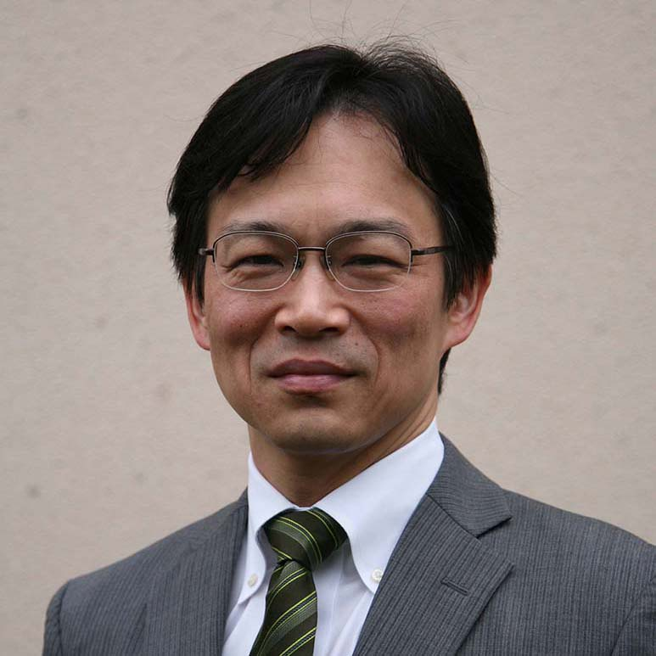Yoshio Hayasaki received PhD from University of Tsukuba, Japan in March 1993. He was a researcher in RIKEN from April 1993 to March 1995. He was an associate professor in The University of Tokushima from April 1995 to March 2008. At present, he is a professor in Utsunomiya University, Center for Optical Research & Education (CORE). He is an optical system designer in the fields of information photonics, optical metrology, and laser material processing. Recently, He is focused to integrate both holographic laser processing system and holographic optical imaging system. He is a fellow member of SPIE and OPTICA, and a member of Optical Society of Japan (OSJ), Japanese Society of Applied Physics (JSAP), Laser Society of Japan (LSJ), Japan Laser Processing Society (JLPS), and The Institute of Electrical Engineers of Japan (IEEJ).